# Getting HydroDesktop Source Code

This tutorial shows how to download HydroDesktop source code and build the HydroDesktop application. It also shows how to upload your changes to the source code repository

## Download TortoiseHG

Install TortoiseHg from <http://tortoisehg.bitbucket.org/>. Note: TortoiseHg is an extension of the Windows Explorer shell, so there is no application to launch.

## HG Clone

To download the HydroDesktop source code:

* 1. Create a new folder on your computer (for example c:\code\HydroDesktop)
  2. Right-click on the folder and select Tortoise HG – Clone

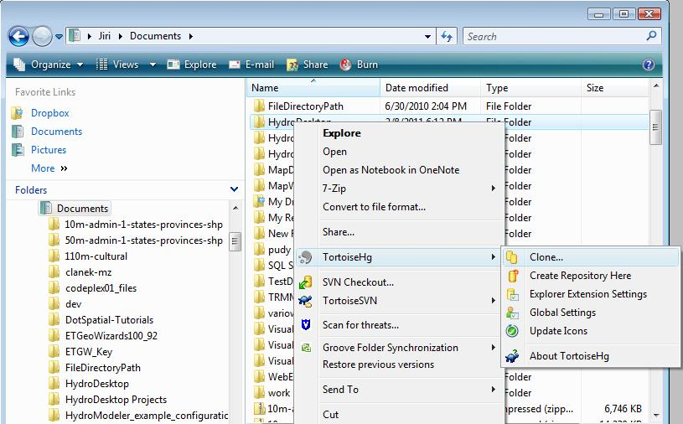

* 1. Set the Source Path to <https://hg01.codeplex.com/hydrodesktop>. Also make sure the option “Use uncompressed transfer” is checked (you can show the option check boxes by clicking on the (+) sign next to “Options” in the Clone dialog window). Click **Clone**. TortoiseHG will download the complete source code from the Codeplex website. This may take several minutes. Once the clone is completed, the dialog will close and you’ll see a green checkmark on the folder.

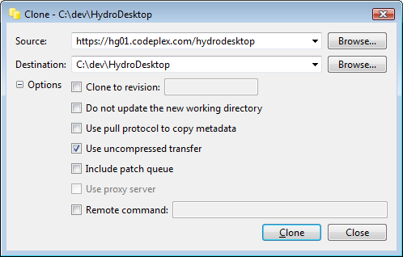

## Build HydroDesktop

### Build the HydroDesktop main application and libraries

Go to the Source\Main subfolder and open the **hydrodestkop.sln** solution file in Visual Studio 2010 (you can use the Visual Studio Express version).

Click Build Solution. A new file **HydroDesktop.exe** is created in the Binaries subfolder.

### Build the HydroDesktop plugins

The source code of the HydroDesktop plugins is located in the **Source\Plugins** subfolder. You can use the **HydroDesktopPlugins.sln** to build all plugins or go to the Source\Plugins\[Plugin Name] subfolder to build each plugin separately.

### Modify the Source Code

When editing the HydroDesktop source code, please conform to the [Good Coding Practices](http://hydrodesktop.codeplex.com/wikipage?title=HydroDesktop%20Good%20Coding) and design guidelines specified at hydrodesktop.codeplex.com website.

## Commit your changes

Uploading your modified code to the HydroDesktop Codeplex repository has two steps: **HG Commit** and **HG Synchronize (Push)**

### HG Commit

In Windows Explorer, right-click on the modified folder or files and select **HG Commit** in the context menu. Notice that the modified folders and files are marked with the red checkmark. In the commit dialog, enter a short description of your change and click **Commit**. If commit is successful, a message ‘finish committing’ appears in the status bar.

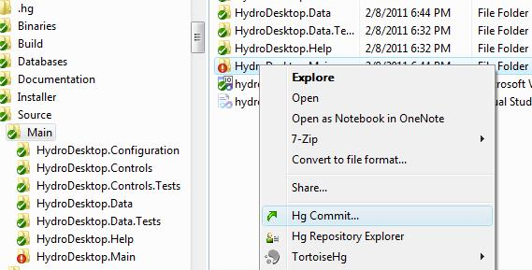

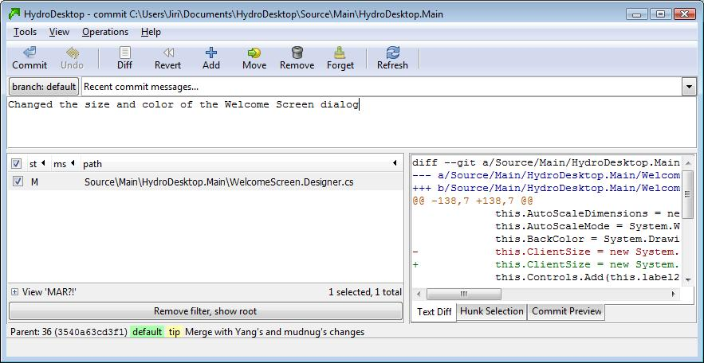

### HG Synchronize

In the main menu of the commit window, select **Tools – Synchronize**. A new window HydroDesktop – synchronize is shown. Click the **Push** button in the main toolbar. Enter your codeplex **user name** and codeplex **password.** This will upload your changes to the codeplex website repository.

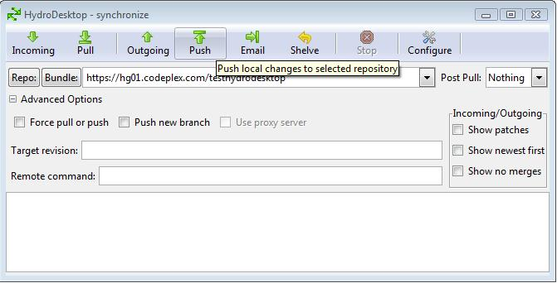

When the upload is complete, a message [command completed successfully] is shown in the synchronize window. You can also check that your upload was successful by visiting the [**Source Code**] tab of the **hydrodesktop.org** website.

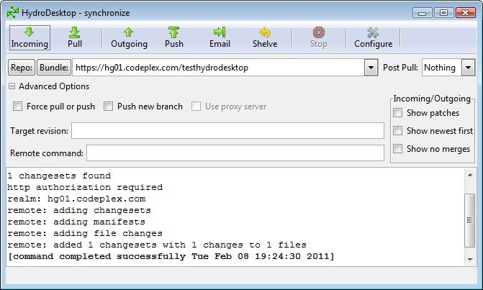

## Update your code

While you were making your changes, some other developers may have modified the HydroDesktop source code files. To keep your local copy of the source code up to date, use the **HG Synchronize (Pull)** and **HG Update** commands.

### TortoiseHG Synchronize (Pull)

Right-click on the HydroDesktop folder and select TortoiseHG – Synchronize. Click the Pull button. This will download any changes from the codeplex source code repository website to your local computer.

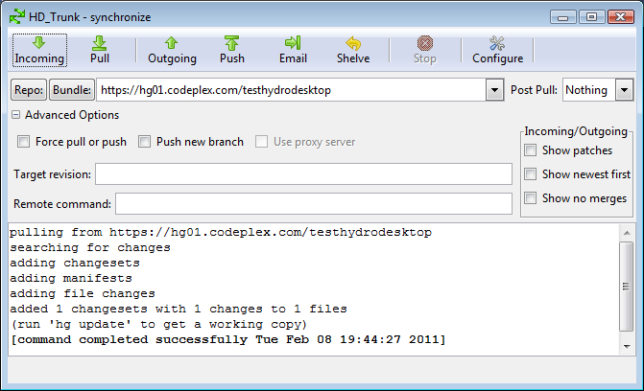

If there were any changes by other developers, a message (run ‘hg update’ to get a working copy) is shown in the status window.

### HG Update

Right click on the HydroDesktop folder and select **Tortoise HG – Update.** Note: If you want to discard all of your local uncommitted changes, check the ‘Discard local changes’ checkbox. Otherwise, leave the checkbox unchecked. Click the Update button to complete the update process.

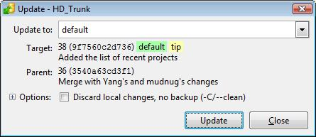

## 6 HG Repository Explorer

The HG Repository explorer shows the recent history of the source code. Notice the branches in the history tree. HydroDesktop uses two main branches: **default** (this is the active development version) and **1.1 Stable release** (this is the stable version). There are also other branches which indicate that two or more developer were working on the source code at the same time.

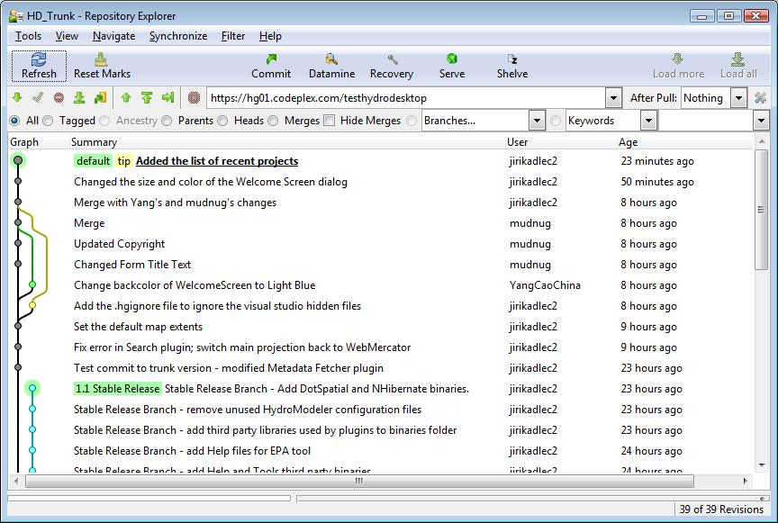

### 6.1 Merge

Sometimes after commit, synchronize –push and synchronize – pull, your change may end up on a branch different from the ‘default’. In this case a Merge is required. For the merge operation, use HG repository explorer. The merge operation has following steps:

6.1.1 Right-click on your changeset and select Update. In the Update To.. drop down, select **default**.

6.2.2 Right-click on your changeset and select **Merge With**.. Click OK

6.2.3 Click Commit

Notice that your branch will become merged back into the main source code tree in the HG repository explorer.

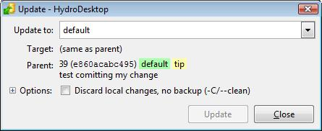

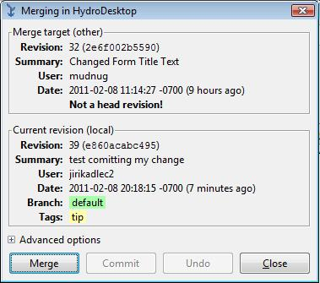

## 7 Getting the source code of the 1.1 Stable Release Branch

To work on the 1.1 Stable release, use the **Tortoise HG – Update** command.

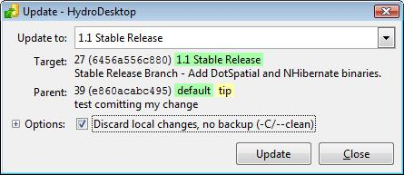

Make sure that the ‘Discard local changes’ option is checked.

The process of Committing your changes to the branch is similar to working with the default source code. Notice that in the HG Commit dialog, you can see the name ‘Branch – 1.1 Stable Release’.



## 7 Useful Links

[Using TortoiseHG with CodePlex](http://codeplex.codeplex.com/wikipage?title=Using%20TortoiseHG%20with%20CodePlex)

[Mercurial and TortoiseHG Video](http://tekpub.com/codeplex)